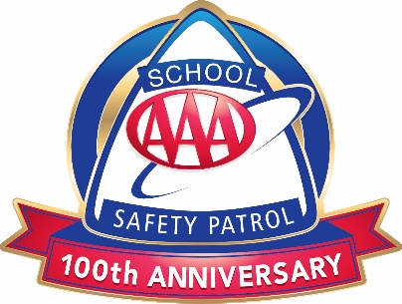

AAA School Safety Patrol Belt Positioning

The official uniform for the AAA School Safety Patrol is the “lectric lime” Sam Browne belt and badge.
- Belts should lay on the right shoulder and buckled in the front.
- Badges should be pinned on the front of the shoulder strap at chest level.
- Badges should only be removed if the belt is being cleaned.
- The printed “Safety Patrol” side of the belt should be on the patroller’s back.

Front View Back View
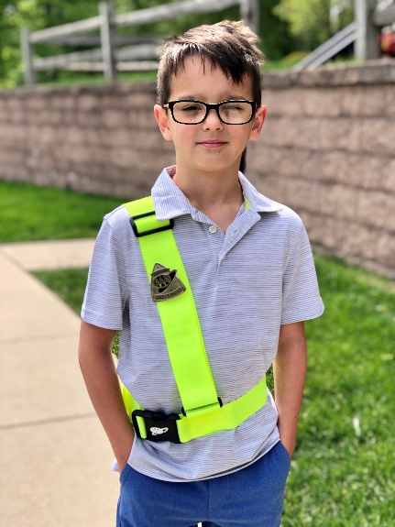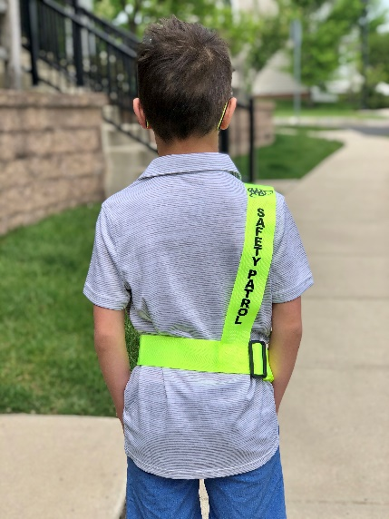

How to Care for AAA School Safety Patrol Equipment
Belts
- Belts should be taken off when not on duty, folded correctly (see instructions below), and kept in a designated place.
- Belts should be cleaned regularly with a damp cloth.
- If a belt needs to be washed:
  - Pour a small amount of liquid or powder soap onto a damp cloth and scrub.
  - Rinse the belt thoroughly.
  - NEVER use a dryer, let your belt air dry.
  - Alcohol and abrasive cleaners should not be used.
Badges
- Badges should only be worn on the front of a AAA School Safety Patrol belt.
- Pin badge on the shoulder strap of the belt at chest level.
- Remove badge only when belt is being cleaned.
- Removing and repining badge multiple times a day will cause it to break.
- Clean badge by washing with mild soap and water and immediately dry with a towel.
- Abrasive polishes should not be used to clean badges

Rain Poncho (optional item)
- Hang poncho on wooden hanger with shoulders centered on hanger arms.
- Hang in a cool dry place away from direct sunlight and heat.
- Ensure the sleeves are straight.
- Do not cuff sleeves as they hold water and may cause cracking or mildew.
- To clean, wipe with a damp cloth only.

How to Fold the AAA School Safety Patrol Belt

- Lay patrol belt on a flat surface and match waist and shoulder sections at front and back. | 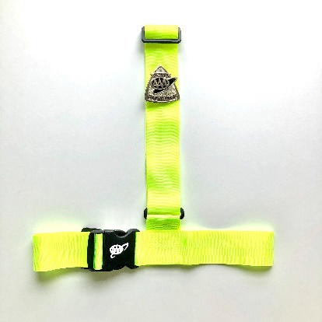
- Fold the right side of the waist portion under the belt. | 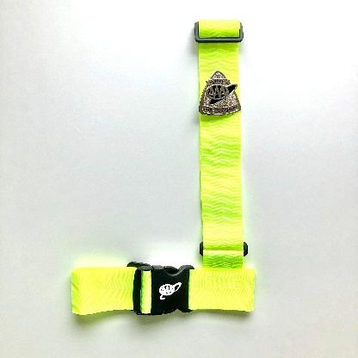
- Fold the left side of the waist portion under the belt. | 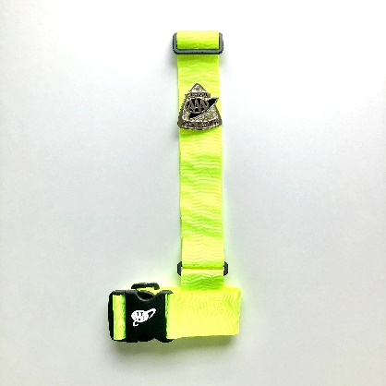
- Wrap the shoulder portion of the belt around the waist section until folded completely. Secure with a rubber band. | 