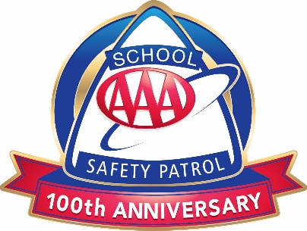

AAA SCHOOL SAFETY PATROL
Operating Guidelines for Starting a Patrol During COVID-19

COVID-19 NOTE: At AAA we recognize and appreciate your dedication to keeping school children safe. Our goal is to provide advisors with the resources needed to easily start and maintain a AAA School Safety Patrol program during COVID-19. Please do not hesitate to reach out to your local traffic safety lead if you have any questions or ideas.

PURPOSE:
The AAA School Safety Patrol is a peer leadership program that builds a sense of citizenship and leadership among its members. Historically, patrollers have worked to keep their school environment safe from posts located throughout the school, both inside and outside of the building. In today’s COVID-19 environment, schools are faced with many obstacles and the AAA School Safety Patrol can play a vital role in the health and safety of all students.

PROGRAM SUMMARY:
- Designate an adult school employee to serve as patrol advisor.
- Students are given an overview of the program and the process for applying virtually or in person (PowerPoint available).
- Students submit application and obtain parent or guardian permission (sample letter available).
- Students are selected by school personnel.
- Patrollers are trained on their patrol responsibilities virtually or in person (PowerPoint available).
- Patrollers are given belts and badges (provided free by AAA).
- School-wide virtual or in person assembly is held to introduce patrol to the school and induct new patrollers.

ORGANIZATION OF PATROL:
- Determine the size of your patrol (No more than 10% of the student population)
  - It is acceptable to lessen the number of patrols during social distancing restrictions if necessary
- Determine hours of duty (a.m., p.m. or both)

SELECTING PATROL MEMBERS:
Look for the following characteristics:
- Leadership, reliability, good scholastic record, courtesy and respect for classmates, desire to help others.
- Assign Captain, Lieutenant, and/or Sergeant (optional).
  - The number of officers is determined by the amount of work required.
    - Adjusted schedules due to COVID-19 may require additional officers.
  - Captain can prepare meeting agenda and check posts.
  - Lieutenant can perform the captain’s duties in the captain’s absence.
  - Sergeant can be responsible for all equipment.

TRAINING PATROL MEMBERS:
Training should consist of the following:
- Overall goal of the patrol, how to care for the uniform, defining a safety hazard, what to do in certain situations, and leadership qualities (PowerPoint available).
- Posts may take on a different format to comply with CDC recommendations. Here are some examples:
  - Classroom/Hall Post
    - Daily check for hand sanitizer, soap, tissues, etc.
    - Remind students to follow school safety rules.
  - Daily Announcements
    - Patrols can participate in school-wide announcements and provide safety messages to the student body.
  - Bus Post
    - Extra set of eyes to remind students of new seating arrangements
  - Extra Responsibilities
    - Patrollers can design posters or lead a poster contest about current safety topics:
      - hand washing
      - coughing/sneezing into elbow vs. hand
      - social distancing on the bus and in school
      - new school bus seating arrangements

INTRODUCING THE NEW SAFETY PATROL PROGRAM:
It is important to introduce the program, along with its new patrol members to help the student body understand what the patrol is about. During social distancing, choose the best way to host a virtual school-wide assembly:
- EXAMPLE: Broadcast the induction ceremony across school televisions or introduce the patrol during daily announcements and highlight one patroller each day.

REWARDING PATROLLERS:
- Certificates and pins are available free of charge from AAA and can be given to patrollers at end-of-year ceremonies.

