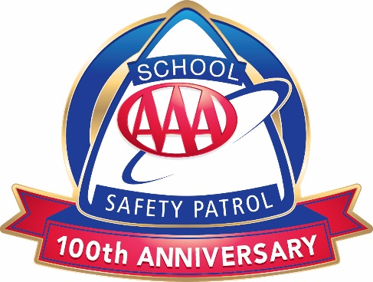
AAA School Safety Patrol Pledge

I promise to do my best to:

- Report for duty on time.
- Perform my duties faithfully.
- Strive to prevent injuries, always setting a good example myself.
- Obey my teachers and officers of the patrol.
- Report dangerous student practices.
- Strive to earn the respect of fellow students.

ADVISOR NOTE: Have students recite the pledge when officially inducted as a AAA School Safety Patrol member.

