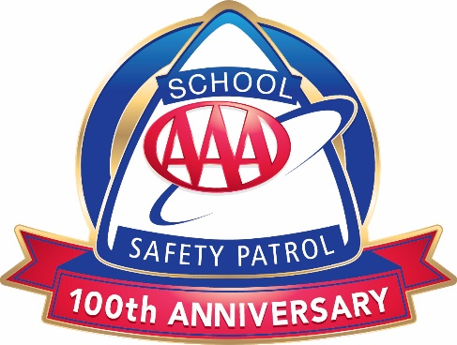
AAA School Safety Patrol Reminders
- Report for duty on time.
- Look, act, and be alert.
- Set a good example by practicing safe behaviors.
- Never stop cars.
- Be dependable and trustworthy.
- Treat others with respect.
- Practice safety on the school bus.
- Be someone others look up to.
- Wear your belt and badge proudly.

ADVISOR NOTE: This document may be used after initial training or throughout the year as needed.

