

AAA SCHOOL

SAFETY PATROL

PLEDGE

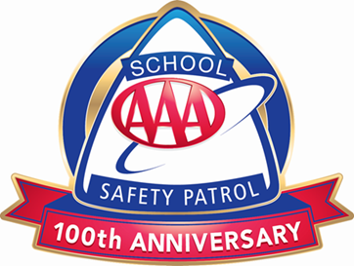

I promise to do my best to:

* Report for duty on time.
* Perform my duties faithfully.
* Strive to prevent injuries, always setting a good example myself.
* Obey my teachers and officers of the patrol.
* Report dangerous student practices.
* Strive to earn the respect of fellow students.

©2020 AAA Club Alliance Inc. 20_661119



AAA SCHOOL

SAFETY PATROL

PLEDGE



I promise to do my best to:

* Report for duty on time.
* Perform my duties faithfully.
* Strive to prevent injuries, always setting a good example myself.
* Obey my teachers and officers of the patrol.
* Report dangerous student practices.
* Strive to earn the respect of fellow students.

©2020 AAA Club Alliance Inc. 20_661119



AAA SCHOOL

SAFETY PATROL

PLEDGE



I promise to do my best to:

* Report for duty on time.
* Perform my duties faithfully.
* Strive to prevent injuries, always setting a good example myself.
* Obey my teachers and officers of the patrol.
* Report dangerous student practices.
* Strive to earn the respect of fellow students.

©2020 AAA Club Alliance Inc. 20_661119



AAA SCHOOL

SAFETY PATROL

PLEDGE



I promise to do my best to:

* Report for duty on time.
* Perform my duties faithfully.
* Strive to prevent injuries, always setting a good example myself.
* Obey my teachers and officers of the patrol.
* Report dangerous student practices.
* Strive to earn the respect of fellow students.

©2020 AAA Club Alliance Inc. 20_661119

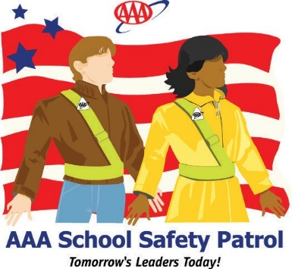

**AAA.com/SchoolSafetyPatrol**

**Seven qualities of a GREAT School Safety Patroller:**

**DEPENDABLE**

Be a person others can rely upon.

**POLITE AND COURTEOUS**

Treat others as you would like to be treated.

**GOOD ROLE MODEL**

Always practice safe behaviors.

**TRUSTWORTHY**

Show integrity, strength, and confidence.

**RESPECTFUL**

Never be bossy or rude.

**PROUD**

Wear the belt and badge with pride; always keeping

it neat and clean.

**DILIGENT**

Work with caution and determination in everything you do.



**AAA.com/SchoolSafetyPatrol**

**Seven qualities of a GREAT School Safety Patroller:**

**DEPENDABLE**

Be a person others can rely upon.

**POLITE AND COURTEOUS**

Treat others as you would like to be treated.

**GOOD ROLE MODEL**

Always practice safe behaviors.

**TRUSTWORTHY**

Show integrity, strength, and confidence.

**RESPECTFUL**

Never be bossy or rude.

**PROUD**

Wear the belt and badge with pride; always keeping

it neat and clean.

**DILIGENT**

Work with caution and determination in everything you do.



**AAA.com/SchoolSafetyPatrol**

**Seven qualities of a GREAT School Safety Patroller:**

**DEPENDABLE**

Be a person others can rely upon.

**POLITE AND COURTEOUS**

Treat others as you would like to be treated.

**GOOD ROLE MODEL**

Always practice safe behaviors.

**TRUSTWORTHY**

Show integrity, strength, and confidence.

**RESPECTFUL**

Never be bossy or rude.

**PROUD**

Wear the belt and badge with pride; always keeping

it neat and clean.

**DILIGENT**

Work with caution and determination in everything you do.



**AAA.com/SchoolSafetyPatrol**

**Seven qualities of a GREAT School Safety Patroller:**

**DEPENDABLE**

Be a person others can rely upon.

**POLITE AND COURTEOUS**

Treat others as you would like to be treated.

**GOOD ROLE MODEL**

Always practice safe behaviors.

**TRUSTWORTHY**

Show integrity, strength, and confidence.

**RESPECTFUL**

Never be bossy or rude.

**PROUD**

Wear the belt and badge with pride; always keeping

it neat and clean.

**DILIGENT**

Work with caution and determination in everything you do.