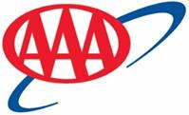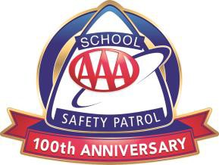

2022-2023 Outstanding AAA School Safety Patrol Award Nomination Form
AAA Club Alliance will recognize exemplary AAA School Safety Patrollers who have excelled in the areas of leadership, dependability and service to others.
Please take the time to complete this form in its entirety.
Advisors may nominate one Patroller per school.
Multiple nominations or nominations submitted by students will not be recognized.
Winners will be recognized at their school if possible and will receive a personalized plaque and gift card in recognition of their achievement.
Here are some tips for writing strong nominations:
- Specific examples of an exemplary Patroller should be very detailed.
- Gather quotes about the nominated student from classmates as well as faculty members.
- Tell us in detail how the student reinforces goals and mission of your school’s School Safety Patrol.
Please send completed forms to our Safety Patrol mailbox by Wednesday, March 15, 2023

County, District, or Township:

Name of School:

Name of Student: Grade Level:

Patrol Rank - Please check one:
Captain
Lieutenant
Sergeant
Patroller

Name, Title, and Email Address of person completing this form:

Using detailed examples, complete the following questions with as much information as possible. Please use additional pages to complete questions. All questions are mandatory.

- Thoroughly describe this Patroller’s leadership style. Please share, with examples, some of the traits and values this Patroller exemplifies that sets him or her apart from all other members of the Patrol while on duty.

- Share two or more specific examples that occurred during the school year, making this Safety Patroller stand out among all others at your school, therefore qualifying him or her for this award.

- List comments from administrators, teachers, fellow students, bus drivers, crossing guards, etc. regarding this Safety Patroller’s performance.

- Please let us know any other information you feel might be relevant to our consideration of your student for the Outstanding School Safety Patrol.

