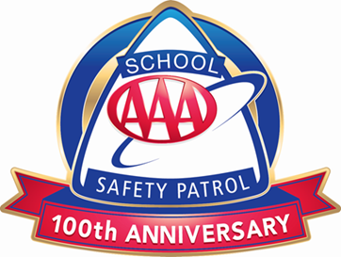
STUDENT NAME: HOMEROOM:
All applicants to the Safety Patrol will be expected to:

- Report for duty on time
- Perform duties faithfully
- Strive to prevent injuries, always setting a good example
- Obey teachers and officers of the patrol
- Report dangerous student practices
- Strive to earn the respect of fellow students

Write a paragraph that explains why you are a good candidate for the Safety Patrol (remember to use character traits, habits, values, or skills):

Indicate how you arrive to school in the morning and how you depart in the afternoon:

Arrive: | □ Bus | □ Parent Drop-off | □ Walk | □ Before Care Program
Depart: | □ Bus | □ Parent Pick-up | □ Walk | □ After Care Program

Ask one of your teachers to sign below as a recommendation for application to the Safety Patrol.

Teacher Signature

My child has permission to participate in the Safety Patrol if he/she is chosen.

Parent/Guardian Signature

To be considered for the School Safety Patrol, this application must be turned in to

by .
(Date)
(Teacher)

©2020 AAA Club Alliance Inc.

